Graph – degree calculation and checking connectivity

import java.util.*;
class MyStack
{LinkedList<Integer> t;
MyStack() {t = new LinkedList<Integer>();}
boolean isEmpty() {return(t.isEmpty());}
void push(int x) {t.add(x);}
int pop() {return(t.removeLast());}
}

class MyQueue
{LinkedList<Integer> t;
MyQueue() {t = new LinkedList<Integer>();}
boolean isEmpty() {return(t.isEmpty());}
void enqueue(int x) {t.add(x);}
int dequeue() {return(t.removeFirst());}
}
class Graph
{int [][] a; int n;
char [] v;
Graph() {v = "ABCDEFGHIJKLMN".toCharArray();a=null;n=0;}
void clear() {a=null;n=0;}
void setData(int [][] b)
{n=b.length; a = new int[n][n];
int i,j;
for(i=0;i<n;i++)
for(j=0;j<n;j++) a[i][j] = b[i][j];
}
void dispAdj()
{int i,j;
System.out.println("\nThe adjacency matrix:");
for(i=0;i<n;i++)
{System.out.println();
for(j=0;j<n;j++) System.out.printf("%5d",a[i][j]);
}
}
void visit(int i) {System.out.print(v[i]+" ");}

void depth(boolean [] visited,int i)
{visit(i);visited[i]=true;
for(int j=0;j<n;j++)
if(!visited[j] && a[i][j]>0) depth(visited,j);
}
void depth(int k)
{boolean [] visited = new boolean[n];
int i,j,r;
r =1;
for(i=0;i<n;i++) visited[i]=false;
System.out.println("\nDepth-first traverse from the vertex " + v[k] + ":");
System.out.println("\nDepth-first traverse for connected part " + r+":");
depth(visited,k);
for(i=0;i<n;i++)
{for(i=0;i<n;i++)
if(!visited[i])
{r++;
System.out.println("\nDepth-first traverse for connected part " + r+":");
depth(visited,i);
}
}
System.out.println();
}
void breadth(int k) // not complete yet
{MyQueue q = new MyQueue();
boolean [] enqueued = new boolean[n];
int i,j;
for(i=0;i<n;i++) enqueued[i]=false;
q.enqueue(k); enqueued[k] = true;
int r;
System.out.println("\nBreadth-first traverse from the vertex " + v[k] + ":");
while(!q.isEmpty())
{r=q.dequeue(); visit(r);
for(j=0;j<n;j++)
if(!enqueued[j] && a[r][j]>0)
{q.enqueue(j); enqueued[j]=true;
}
}
System.out.println();
}
boolean isConnected()
{MyStack s = new MyStack();
boolean [] pushed = new boolean[n];
int i,j,r;
for(i=0;i<n;i++) pushed[i]=false;
s.push(0); pushed[0]=true;
while(!s.isEmpty())
{r=s.pop();
for(i=0;i<n;i++)
if(!pushed[i] && a[r][i]>0) {s.push(i);pushed[i]=true;}
}
for(i=0;i<n;i++)
if(!pushed[i]) return(false);
return(true);
}
int degree(int k)
{int j,s;
s=0;
for(j=0;j<n;j++)
if(a[k][j]>0) s++;
if(a[k][k]>0) s++;
return(s);
}
}

public class Main
{public static void main(String [] args)
{Graph g = new Graph();
int [][] b = {
{0,1,1,0,1},
{1,0,1,0,0},
{1,1,0,1,0},
{0,0,1,0,0},
{1,0,0,0,0},
};
g.setData(b);
g.depth(0);
g.breadth(1);
int [][] c =
{
{0, 0, 0, 0, 1, 1, 1, 0, 1},
{0, 0, 0, 0, 0, 0, 1, 0, 1},
{0, 0, 0, 0, 0, 0, 0, 1, 0},
{0, 0, 0, 0, 0, 0, 0, 1, 0},
{1, 0, 0, 0, 0, 1, 0, 0, 1},
{1, 0, 0, 0, 1, 0, 0, 0, 1},
{1, 1, 0, 0, 0, 0, 0, 0, 0},
{0, 0, 1, 1, 0, 0, 0, 0, 0},
{1, 0, 0, 0, 1, 1, 0, 0, 0}
};
Graph h = new Graph();
h.clear();
h.setData(c);
h.depth(0);
h.breadth(1);
System.out.println("Is G is connected? " + g.isConnected());
System.out.println("Is H is connected? " + h.isConnected());

System.out.println("Degree of the vertex A in H is " + h.degree(0));
System.out.println();
}
}

The graph with the adjacency matrix c:
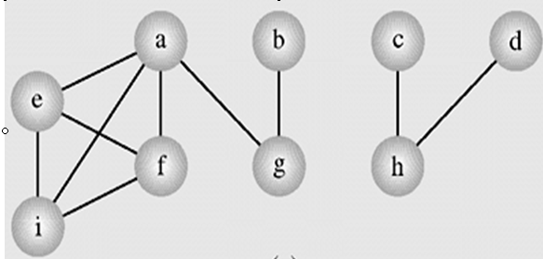

The output of the above program:

